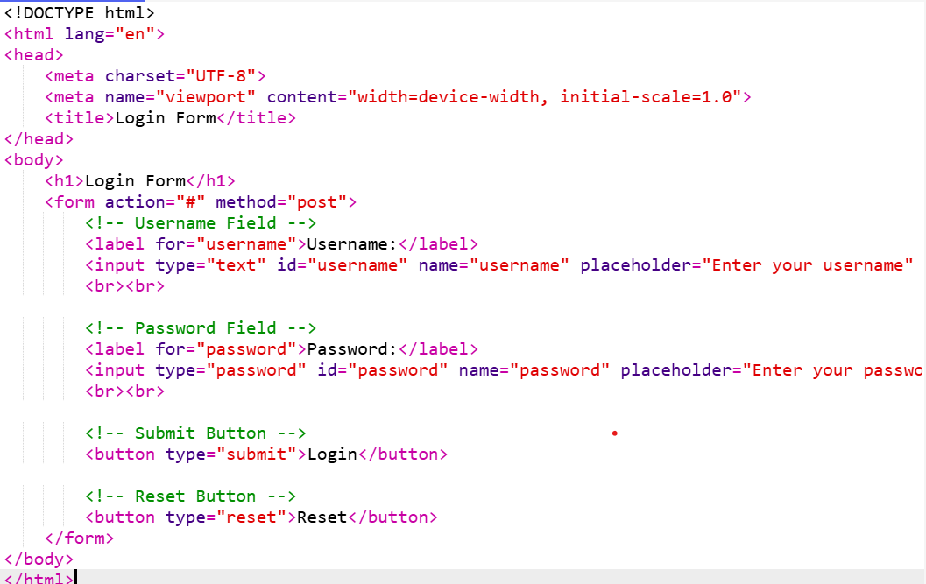

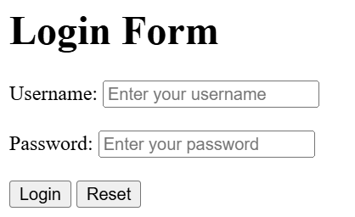

<!DOCTYPE html>

<html lang="en">

<head>

<meta charset="UTF-8">

<meta name="viewport" content="width=device-width, initial-scale=1.0">

<title>Login Form</title>

</head>

<body>

<h1>Login Form</h1>

<form action="#" method="post">

<!-- Username Field -->

<label for="username">Username:</label>

<input type="text" id="username" name="username" placeholder="Enter your username" required>

<br><br>

<!-- Password Field -->

<label for="password">Password:</label>

<input type="password" id="password" name="password" placeholder="Enter your password" required>

<br><br>

<!-- Submit Button -->

<button type="submit">Login</button>

<!-- Reset Button -->

<button type="reset">Reset</button>

</form>

</body>

</html>